**LAB Task 1 (In-LAB Task):**

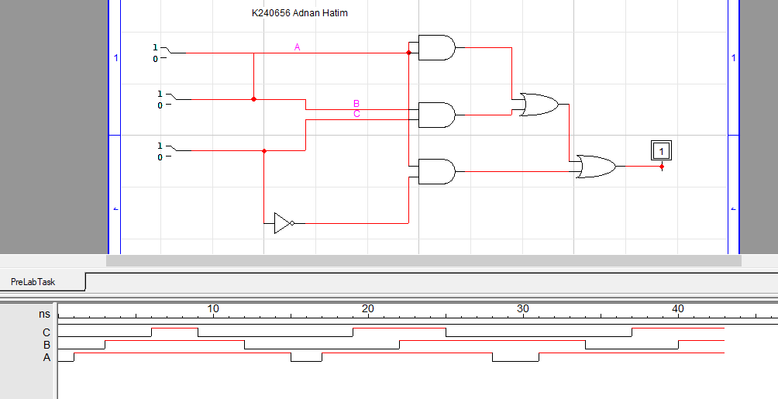

**LAB Task 2 (In-LAB Task):**

**Boolean Expression:**

**((AB + CD)’ + B’) * C’**

**Truth Table:**

|  |  |  |  |  |
| --- | --- | --- | --- | --- |
| A | B | C | D | X |
| 0 | 0 | 0 | 0 | 1 |
| 0 | 0 | 0 | 1 | 1 |
| 0 | 0 | 1 | 0 | 0 |
| 0 | 0 | 1 | 1 | 0 |
| 0 | 1 | 0 | 0 | 1 |
| 0 | 1 | 0 | 1 | 1 |
| 0 | 1 | 1 | 1 | 0 |
| 1 | 0 | 0 | 0 | 1 |
| 1 | 0 | 0 | 1 | 1 |
| 1 | 0 | 1 | 0 | 0 |
| 1 | 0 | 1 | 1 | 0 |
| 1 | 1 | 0 | 0 | 0 |
| 1 | 1 | 0 | 1 | 0 |
| 1 | 1 | 1 | 0 | 0 |
| 1 | 1 | 1 | 1 | 0 |
| 0 | 1 | 1 | 0 | 0 |

**Design:**

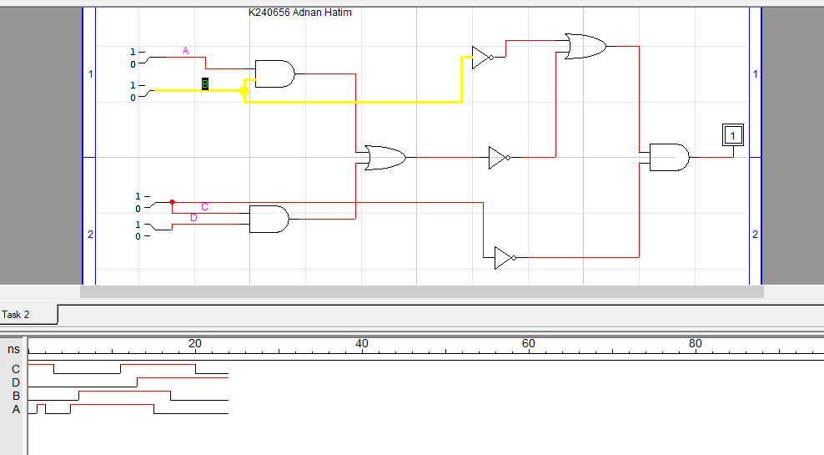

**LAB TASK 3 (In-Lab Task):**

**Design:**

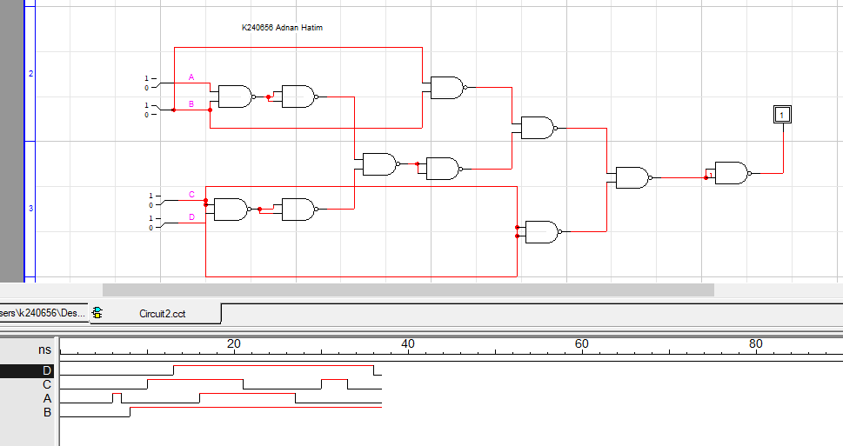

**Truth Table (Verified):**

|  |  |  |  |  |
| --- | --- | --- | --- | --- |
| A | B | C | D | X |
| 0 | 0 | 0 | 0 | 1 |
| 0 | 0 | 0 | 1 | 1 |
| 0 | 0 | 1 | 0 | 0 |
| 0 | 0 | 1 | 1 | 0 |
| 0 | 1 | 0 | 0 | 1 |
| 0 | 1 | 0 | 1 | 1 |
| 0 | 1 | 1 | 1 | 0 |
| 1 | 0 | 0 | 0 | 1 |
| 1 | 0 | 0 | 1 | 1 |
| 1 | 0 | 1 | 0 | 0 |
| 1 | 0 | 1 | 1 | 0 |
| 1 | 1 | 0 | 0 | 0 |
| 1 | 1 | 0 | 1 | 0 |
| 1 | 1 | 1 | 0 | 0 |
| 1 | 1 | 1 | 1 | 0 |
| 0 | 1 | 1 | 0 | 0 |

**LAB TASK 4 (In-LAB TAsk):**

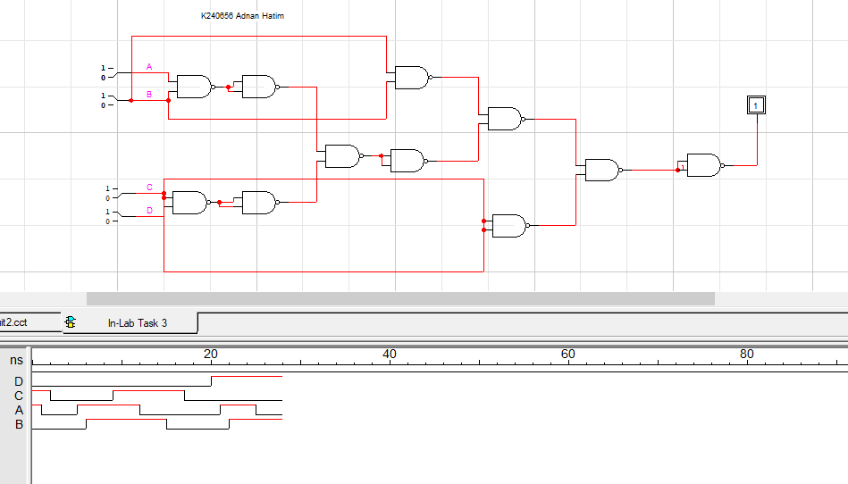

**Truth Table (Verified):**

|  |  |  |  |  |
| --- | --- | --- | --- | --- |
| A | B | C | D | X |
| 0 | 0 | 0 | 0 | 1 |
| 0 | 0 | 0 | 1 | 1 |
| 0 | 0 | 1 | 0 | 0 |
| 0 | 0 | 1 | 1 | 0 |
| 0 | 1 | 0 | 0 | 1 |
| 0 | 1 | 0 | 1 | 1 |
| 0 | 1 | 1 | 1 | 0 |
| 1 | 0 | 0 | 0 | 1 |
| 1 | 0 | 0 | 1 | 1 |
| 1 | 0 | 1 | 0 | 0 |
| 1 | 0 | 1 | 1 | 0 |
| 1 | 1 | 0 | 0 | 0 |
| 1 | 1 | 0 | 1 | 0 |
| 1 | 1 | 1 | 0 | 0 |
| 1 | 1 | 1 | 1 | 0 |
| 0 | 1 | 1 | 0 | 0 |